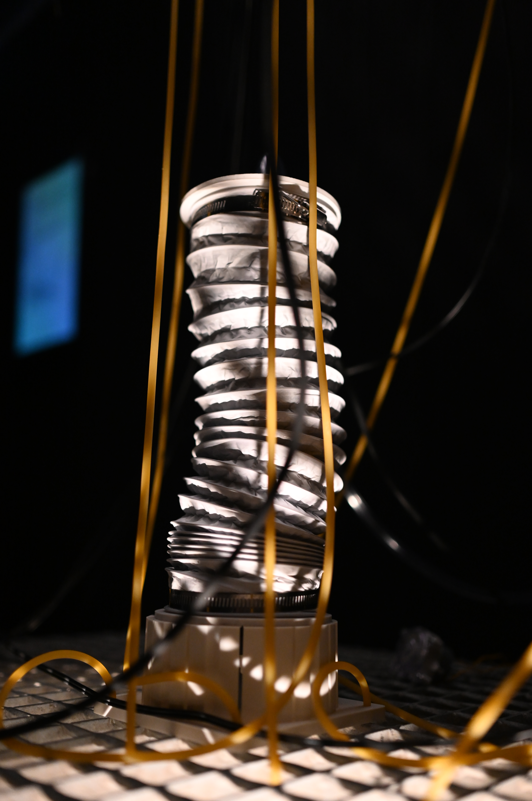
Entering Mauricio’s work is not simply entering a space — it is entering a state.
The light shifts, dimmed and trembling. The air feels cooler, closer. A spotlight rests on a single object: a pale, breathing form mounted within a steel frame. The slow contraction and expansion of its body draws you in, holding your attention in a rhythm that is both soothing and faintly disturbing.
Sound is everywhere — a low, resonant breath layered with the mechanical rattle of pumps, the gentle throb of motors, the persistent hum of hidden systems. Two chairs face the apparatus like a bedside vigil. From this position, the installation feels almost like a life-support system, an intimate encounter with something at once fragile and machine-bound. Outside the room, a window reveals the control panel — the architecture that sustains the work. In a corner, a pair of headphones offers another channel: a delicate weaving of recorded voice and live sound from the breathing device itself.
Mauricio’s practice operates in this liminal zone between human and machine, intimacy and distance. His installations do not whisk you away to a fantastical elsewhere; instead, they deepen the present moment until it becomes strange. You are invited to witness — and in witnessing, to reflect on — the complex codependency of humans and technology, and the terms on which we live with it.
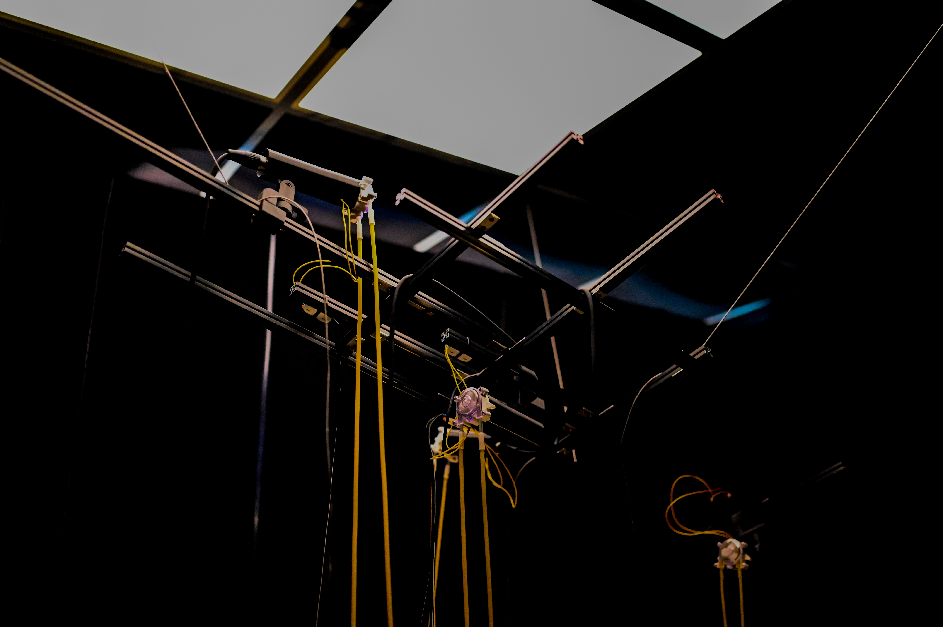
Sitting in front of the slow pulse of the breathing mechanism, one might drift into thoughts of mortality, memory, and submission to forces larger than oneself. It is a meditation that can be both calming and unsettling — a reminder that technology is not a neutral tool, but a partner in shaping our emotional and existential landscapes.
No matter the materials — steel, tubing, circuitry, air — Mauricio’s real medium is the lived, sensory encounter. The work’s precision and craft serve something larger: a space for reflection, connection, and questioning. Through his hands, the instruments of industry become instruments of perception, bringing into focus not only what we see and hear, but how we feel in relation to the systems we inhabit.

